REGISTRATION FORM

Return To first Medicines
3nd annual Gathering
“Remembering What We Always Knew”
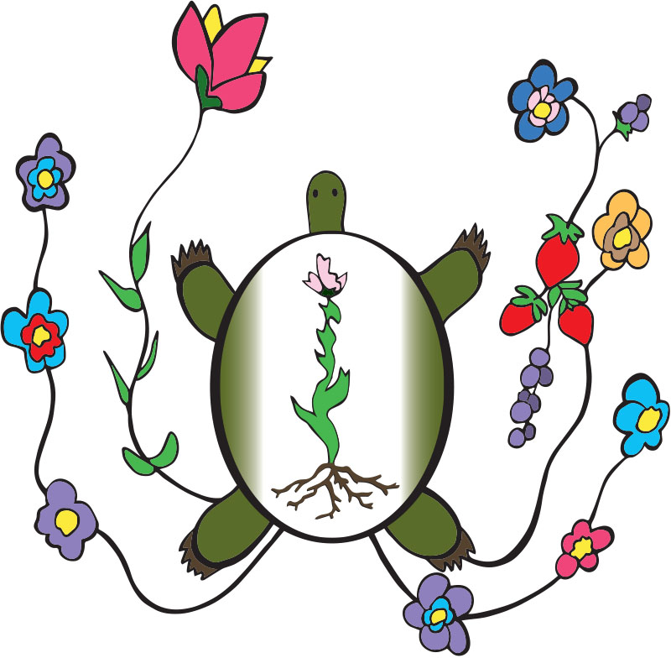
Indigenous Peoples Task Force & Seeds Network
Research for Indigenous Health
Hosting This Event On
August 17, 18, 2016
Fortune Bay Resort & Casino
1430 Bois Forte Rd, Tower, MN 55790
A block of hotel rooms has been arranged at a reduced rate at Fortune Bay Resort.
Reservations can be made at 800-555-1714 and referencing the First Medicines Gathering
RV & Camping sites are available but not reserved.

Mail payment to: Indigenous Peoples Task Force
Attn: First Medicines Conference
1335 E. 23rd Street
Minneapolis, MN 55404
Registration Fee: $40.00.
Please write “First Medicines Conference” on your check or purchase order and make payable to Indigenous Peoples Task Force
No cash or credit cards.

Name:

Organization:

Address:

City: State: Zip Code:

Job Title:

Phone Fax

Email

Tribal Affiliation (If any):
Please check the days you will be attending:

Wednesday, August 17, 2016
Thursday, August 18, 2016

Please check one:
_____Elder
_____Adult
_____Youth

For questions contact Suzanne Nash at (612) 722-6248 or SuzanneN@indigenouspeoplestf.org

