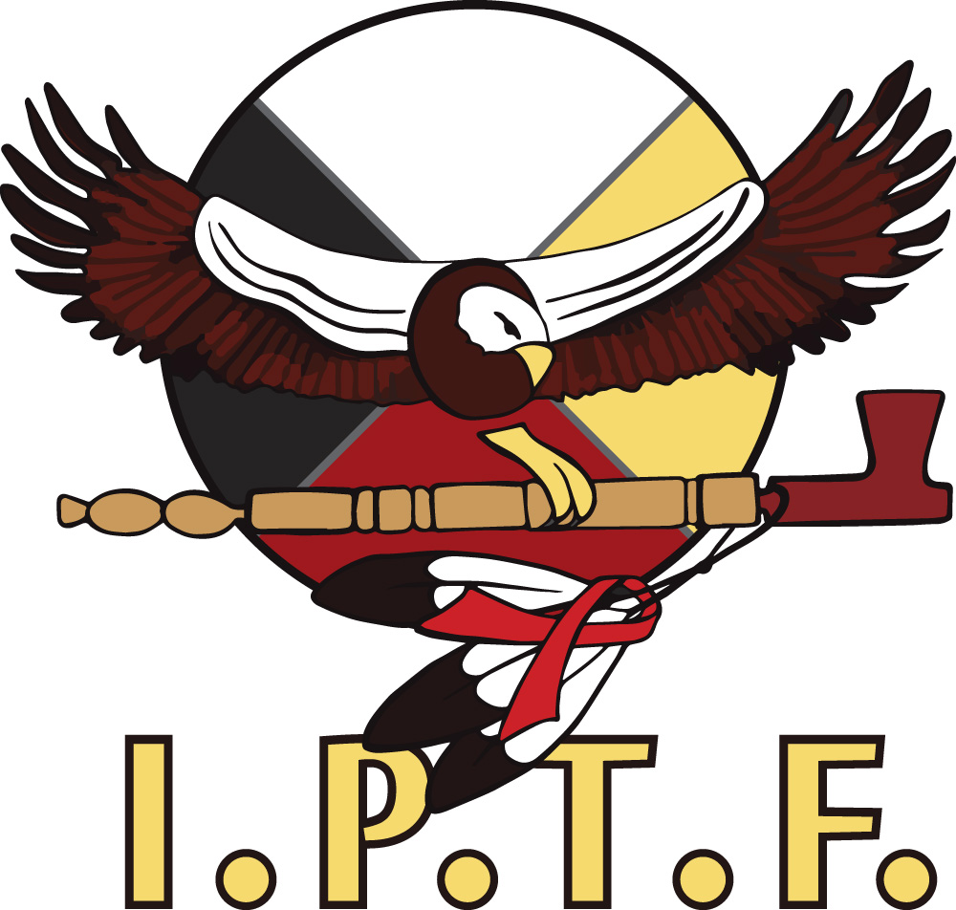  IPTF Agency Logo 2014  CASE MANAGEMENT SERVICES:  - Getting individuals linked to care  - Provide transportation to and from Medical appointments and Food Shelves  - 10 Ride bus passes to assist with medical transportation  - Access to Health Insurance  - Referrals to Every Penny Counts and Aliveness and other agencies  - Cultural/emotional support and health education/risk prevention services  - Housing Referrals  - Assisting in filling out paperwork  - Access to traditional/spiritual counseling  - Locating a suitable doctor who is knowledgeable about HIV/AIDS  - Care Plans/ Advocacy |  |  | ABOUT US:  Indigenous Peoples Task Force (IPTF) is a Native American agency that provides culturally appropriate emotional support and health education/risk reduction services for Native and All American persons living with HIV/AIDS in the Minneapolis/St. Paul area as well as HIV+ people living outside of Minnesota; including all Reservations.  The IPTF services emphasize traditional aspects of health and well-being as western medical models of HIV treatment and care.  Contact Us  Phone: 612-889-4636  Email: candiceb@indigenouspeoplestf.org  Web: www.indigenouspeoplestf.org  Indigenous Peoples task Force  1335 E. 23rd St. Minneapolis, MN 55404 |  |  | Indigenous Peoples task Force  - Strengthening and Enhancing the Health and Education of Native People.

Ganawenima  (To Take Care Of)  Whether newly diagnosed or multi-year HIV survivor, living with HIV/AIDS can be confusing and involve a wide variety of issues.  Together HIV+ clients, Case Manager plan and coordinated with the appropriate services and resources that might be needed to achieve a healthier life.  Culturally sensitive and confidential support is offered individually and or as a group through different activities, such as client retreats, crafts and educational sessions.  IPTF Case Management services increase and sustain emotional well-being, provide psychological and emotional support. These opportunities include talking circles, Ceremonies and traditional feasts which help to reduce social isolation, stigma and promote general well-being. |  |  | The Case Management Program is now offering “Refer-A-Friend”… client incentives for new and existing clients….  New clients will receive a Target gift card for enrolling in Case Management. You must complete all IPTF paperwork and either have a positive confirmatory test or have most recent labs sent to Case Manager.  Existing clients will also receive a Target gift card for referring a client into Case Management. |  |  | 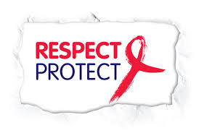  HIV Awareness artwork and above photo(google 2014)  Other Programs Offered:  - Confidential FREE HIV testing, Counseling & referrals  - •Wabinigay Prevention and Cessation Program for native american Youth and young adults  - Gikkinoo-amaage-gidiwin Gitigaan, " The Teaching Garden"​

